Polarizing Microscope
A petrographic microscope is usually a modified compound microscope, although stereo microscopes can also be altered to achieve polarization.
This microscope differs from others because it contains the following components:
- A polarizer and analyzer
- A circular rotating stage
- Special plates or filters placed between the object and light path.
- Bertrand lens
A polarizer only allows certain light waves or vibrations to pass through it.
An analyzer, often a second polarizer located above the sample, determines the amount and direction of light that illuminates a sample.
At its most basic, the polarizer focuses the different wavelengths and vibrations of light onto a single plane.
The relationship of the polarizer and analyzer, in addition to possible filters added, determines the amount of light absorbed, reflected, refracted and/or transmitted through the microscope.
A polarizing microscope can employ transmitted and reflected light.
Transmitted light refers to the light diffused from below the specimen. This light is often passed through a condenser, which allows the viewer to see an enlarged contrasted image.
Reflected light, sometimes referred to as epi- or incidental light, is best suited for opaque samples, such as metals, alloys, composites and mineral oxides and sulfides.
Polarized microscopy is primarily used in the field of geology or petrography for the study of rocks and minerals, but has many other applications. Additional science fields that benefit from polarization include medicine, chemistry, biology and metallurgy.
Polarized light is a contrast-enhancing technique that improves the quality of the image obtained with birefringent materials when compared to other techniques such as darkfield and brightfield illumination, differential interference contrast, phase contrast, Hoffman modulation contrast, and fluorescence. Polarized light microscopes have a high degree of sensitivity and can be utilized for both quantitative and qualitative studies targeted at a wide range of anisotropic specimens. Qualitative polarizing microscopy is very popular in practice, with numerous volumes dedicated to the subject. In contrast, the quantitative aspects of polarized light microscopy, which is primarily employed in crystallography, represent a far more difficult subject that is usually restricted to geologists, mineralogists, and chemists. However, steady advances made over the past few years have enabled biologists to study the birefringent character of many anisotropic sub-cellular assemblies.
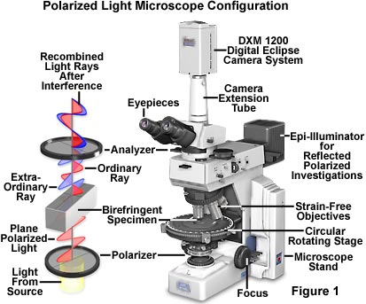
The polarized light microscope is designed to observe and photograph specimens that are visible primarily due to their optically anisotropic character. In order to accomplish this task, the microscope must be equipped with both a polarizer, positioned in the light path somewhere before the specimen, and an analyzer (a second polarizer; see Figure 1), placed in the optical pathway between the objective rear aperture and the observation tubes or camera port. Image contrast arises from the interaction of plane-polarized light with a birefringent (or doubly-refracting) specimen to produce two individual wave components that are each polarized in mutually perpendicular planes. The velocities of these components, which are termed the ordinary and the extraordinary wavefronts (Figure 1), are different and vary with the propagation direction through the specimen. After exiting the specimen, the light components become out of phase, but are recombined with constructive and destructive interference when they pass through the analyzer. These concepts are outlined in Figure 1 for the wavefront field generated by a hypothetical birefringent specimen. In addition, the critical optical and mechanical components of a modern polarized light microscope are illustrated in the figure.
Polarized light microscopy is capable of providing information on absorption color and optical path boundaries between minerals of differing refractive indices, in a manner similar to brightfield illumination, but the technique can also distinguish between isotropic and anisotropic substances. Furthermore, the contrast-enhancing technique exploits the optical properties specific to anisotropy and reveals detailed information concerning the structure and composition of materials that are invaluable for identification and diagnostic purposes.
Isotropic materials, which include a variety of gases, liquids, unstressed glasses and cubic crystals, demonstrate the same optical properties when probed in all directions. These materials have only one refractive index and no restriction on the vibration direction of light passing through them. In contrast, anisotropic materials, which include 90 percent of all solid substances, have optical properties that vary with the orientation of incident light with the crystallographic axes. They demonstrate a range of refractive indices depending both on the propagation direction of light through the substance and on the vibrational plane coordinates. More importantly, anisotropic materials act as beamsplitters and divide light rays into two orthogonal components (as illustrated in Figure 1). The technique of polarizing microscopy exploits the interference of the split light rays, as they are re-united along the same optical path to extract information about anisotropic materials.
- See more at: http://www.microscopemaster.com/polarizing-microscope.html#sthash.yRmgJjUJ.dpuf

